**Comparing NoSQL MongoDB to an SQL**

NoSQL database solutions are becoming more and more prevalent in a world currently dominated by SQL relational databases. NoSQL databases were designed to provide database solutions for large volumes of data that is not structured. However, the advantages (or disadvantages) of using a NoSQL database for data that is structured, and not necessarily “Big,” is not clear. This overview for this article would be discussing various points, pros and cons regarding NoSQL database MongoDB and other traditional databases. The relational model is built on this assumption of structured data, with its data stored in the rows and columns of a table, whereby each row has the same number and type of data columns. Tables in relational databases are typically normalized, which results in the creation of multiple tables. Querying those tables requires fetching and combining information from the many different tables. Combining information based on a matching value for a primary key and foreign key across multiple tables in the relational model requires using a join operation. The larger the schema and the more tables that need to be joined, the longer it takes for the relational database to fetch the data. NoSQL can help deal with data that is not structured. Data can be semi-structured, such that similar data objects can be grouped together, but the objects may have different characteristics. When using the NoSQL implementation MongoDB, there are no database schemas or tables. MongoDB instead uses a “collection” which is similar to a table and “documents” which are like rows, to store the data and schema information. The typical features of SQL databases, such as the ACID properties, require a certain amount of overhead, and are relaxed or eliminated in NoSQL databases to maximize performance. Many NoSQL databases organize the data into key-value pairs. The development of queries is more complex, there is no standard query language, and there are limits to the operations. Specifically, there is no join operation. However, in general processing is simpler, more affordable and more flexible. While Many relational databases provide ACID properties, MongoDB only provides atomic operations within a single document. Another major feature MongoDB does not have many of the simple aggregate functions while databases like MySQL has a good support for aggregate functions. MongoDB automatically generates a primary key (id) to uniquely identify each document. The id and document are conceptually similar to a key-value pair. MongoDB attempts to hold most of the data in memory so simple queries take less time by eliminating the need to retrieve data from the hard disk. One caveat to this is once the data set becomes larger than the available memory, then MongoDB will have to start querying the hard disk for results. Since MongoDB is a NoSQL implementation, it is highly scalable and does not require a rigid schema definition. This can sometimes make queries more difficult to write because the user may not know exactly which parts of the document to query. MapReduce is a programming abstraction which is used today to process big data with MongoDB. MapReduce consists of two stages: the Map stage in which the user specifies computation to be applied over all the input and the Reduce phase, in which the output from the Map phase is aggregated using another user specified computation. Various Experiments were carried out to get the results between the two databases with the graphs showing differences in the insert speed and the runtimes. The SQL processing time of the query becomes much slower than the lookup of MongoDB as the amount of data increases. Since SQL Server must retrieve all its data, disk speed is slower than memory fetch time, MongoDB outperforms SQL. In conclusion, MongoDB could be a good solution for larger data sets and the choice for users who need a less rigid database structure. MongoDB has better runtime performance for inserts, updates and simple queries. SQL performed better when updating and querying non-key attributes, as well as for aggregate queries. However, there were downsides to MongoDB, such as its poor performance for aggregate functions and querying based on non-key values. Also, MongoDB required additional effort in implementation compared to SQL and required decisions that affected its performance. Lastly, SQL is the industry standard and much more widely supported over MongoDB.

**Data Aggregation System**

Data Aggregation System is a system for information retrieval and aggregation from heterogenous sources of relational and non-relational data. DAS provides a single interface for querying all these services, a caching layer to speed up access to expensive underlying calls and the ability to merge records from different data services pertaining to a single primary key. In terms of Architecture, DAS is an additional layer on top of a heterogenous ecosystem of existing CMS data services. It was designed as a series of independent components, which can scale from running on a single node to multiple nodes and duplicate components. The web server handles user sessions, whether they originate from a browser or automated scripts. The cache server consists of a pool of worker threads which handle the DAS queries received from the web front-end. The analytics server provides a facility for scheduling regular tasks. DAS queries are made in a custom text-based language. To make a query, a user must know which DAS key describes the data they are seeking. Each data service used by DAS is described in a mapping document (supplied in YAML format) which describes the functions available, the mapping from input DAS keys to actual arguments, and finally a mapping from the returned keys back to DAS keys. Data in DAS is principally stored in two separate collections; the raw and merged caches. The DAS analytics system is a daemon that schedules and executes small tasks that access the DAS document store. To benchmark DAS performance, a 64-bit Linux node with 8 cores (each 2.33GhZ) and 16GB of RAM, which we would expect to be typical of the hardware DAS would use in production. All DAS systems and MongoDB share this node.

**PROGRAMMING:**

Create a collection called ‘games’. We’re going to put some games in it.  
Add 5 games to the database. Give each document the following properties: name, genre, rating (out of 100)  
If you make some mistakes and want to clean it out, use remove() on your collection.

ANSWER:

1. Starting mongo and creating db

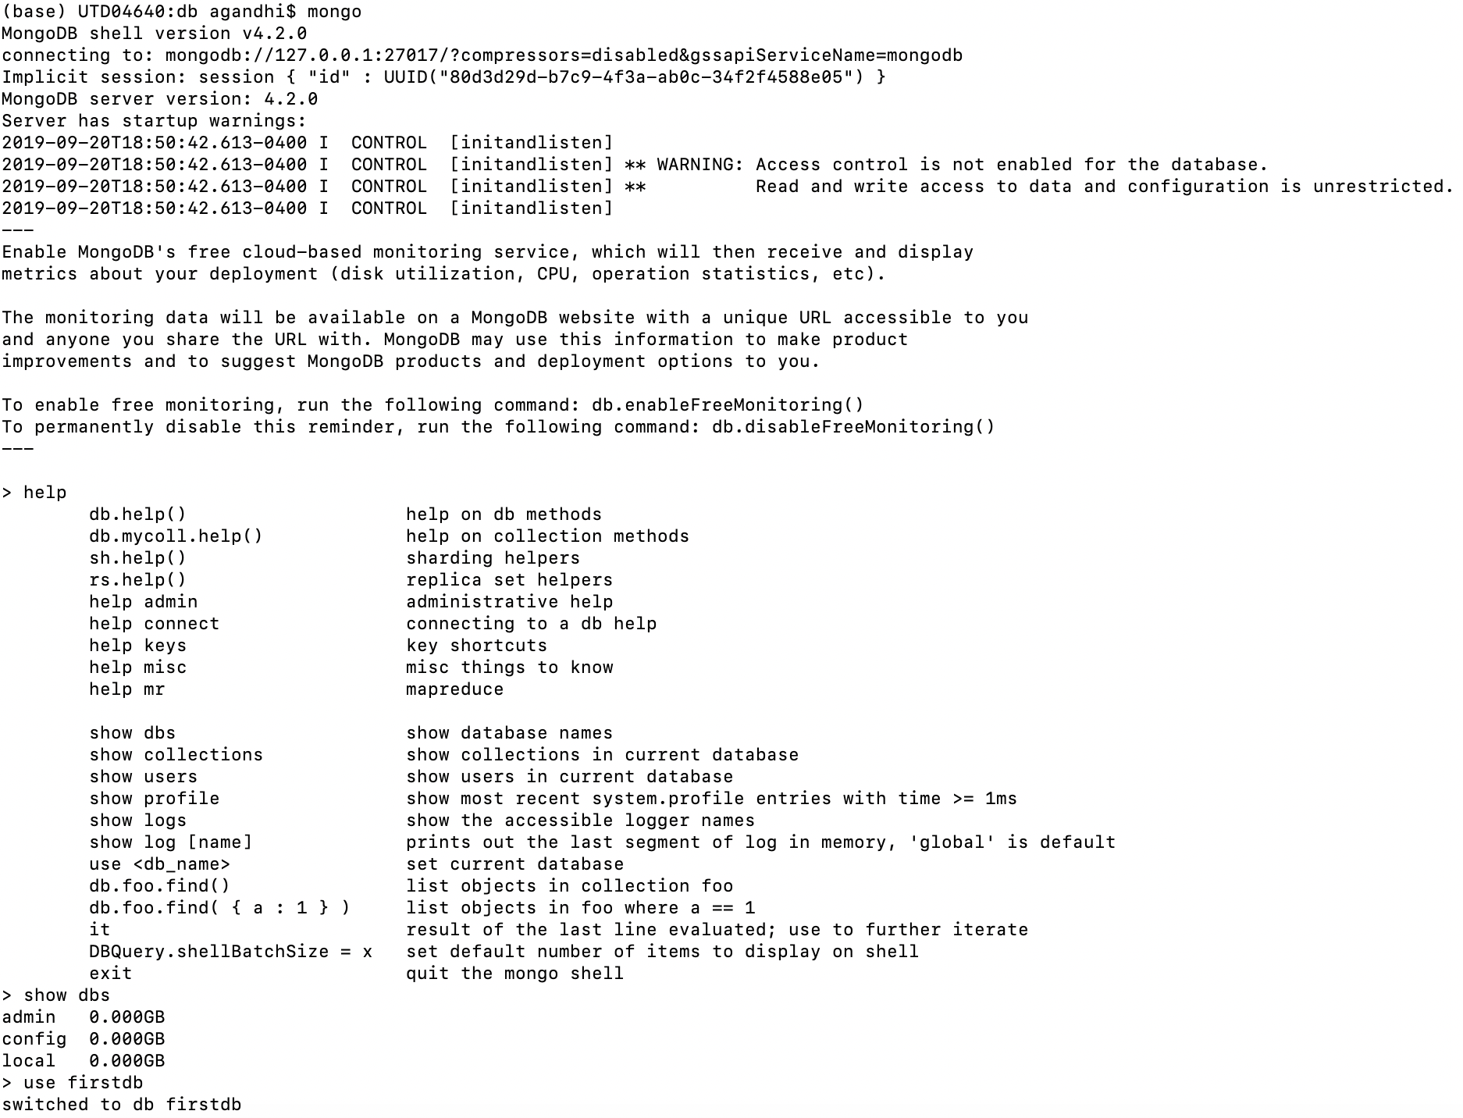

1. Creating Collection and inserting 5 games with mentioned properties –

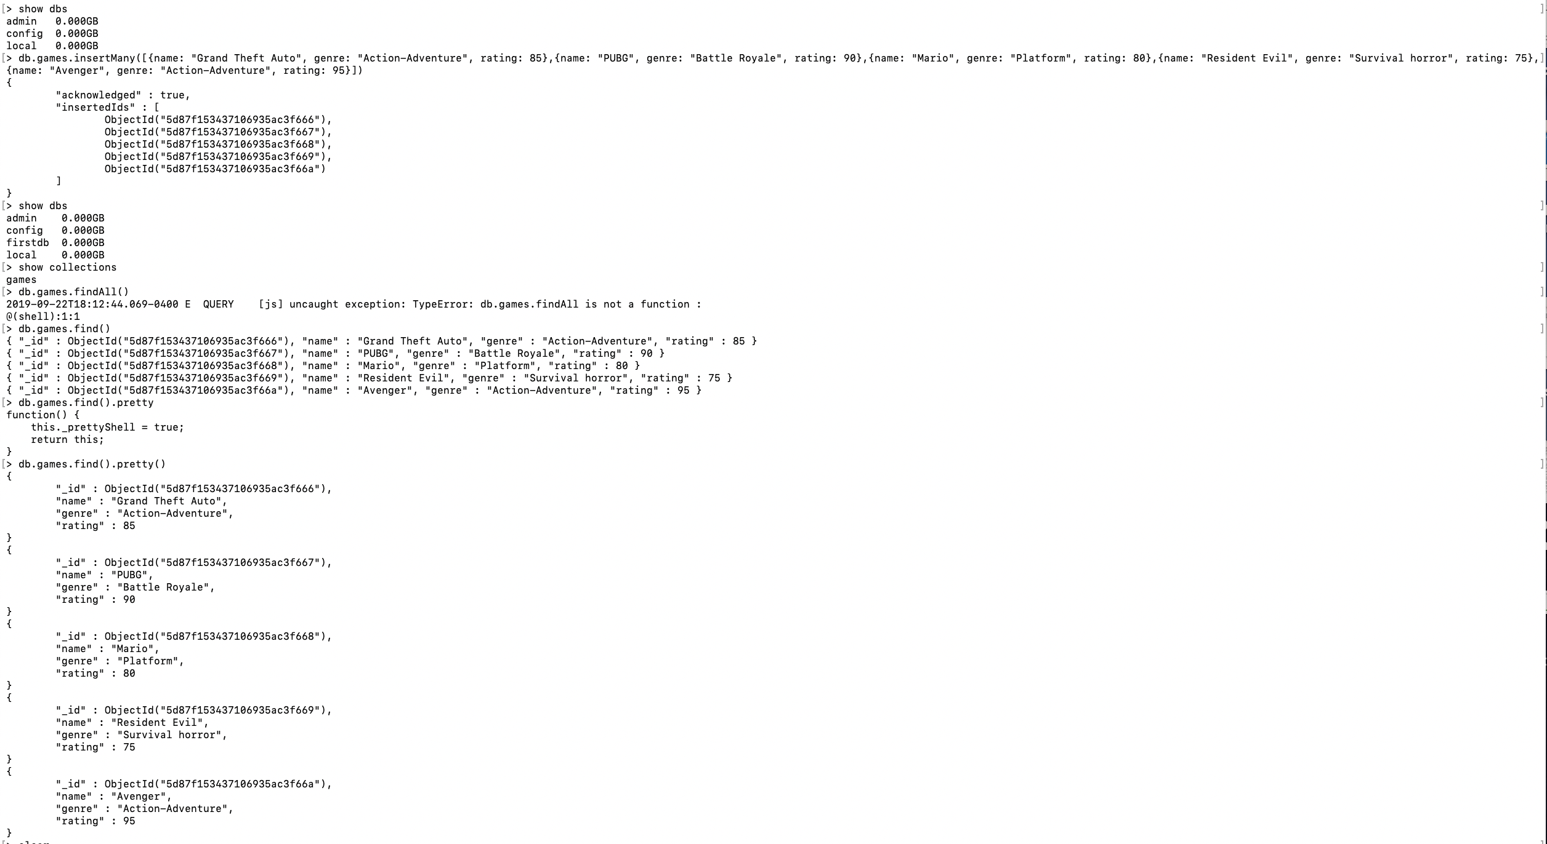

Write a query that returns all the games.

ANSWER:

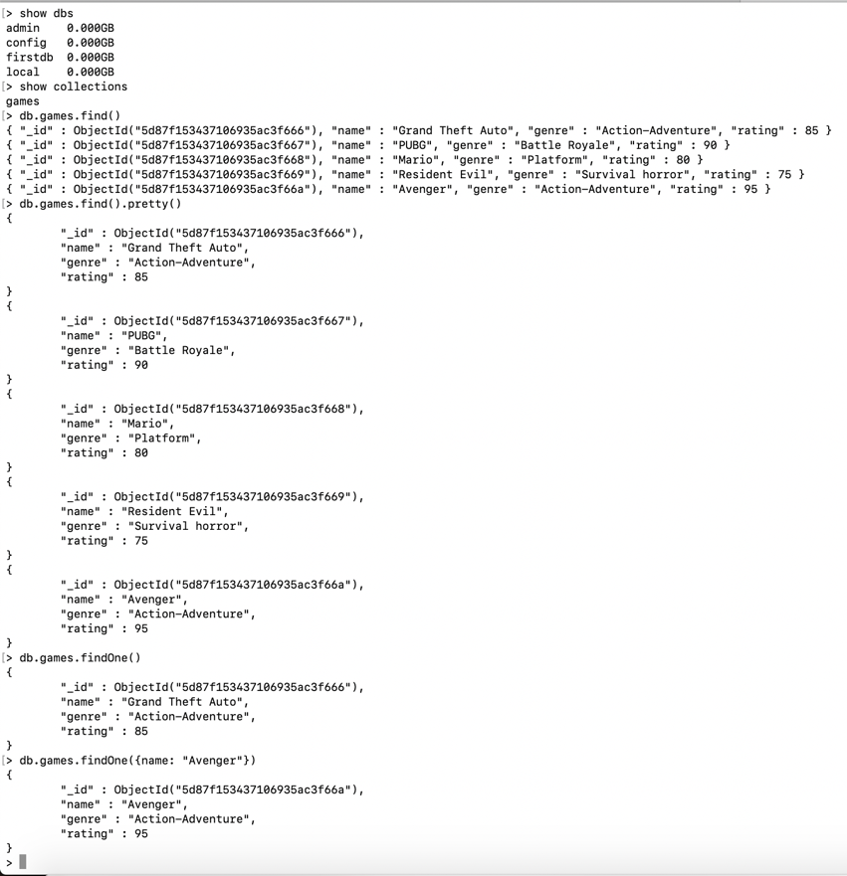

Write a query to find one of your games by name without using limit().

Use the findOne method.

ANSWER:

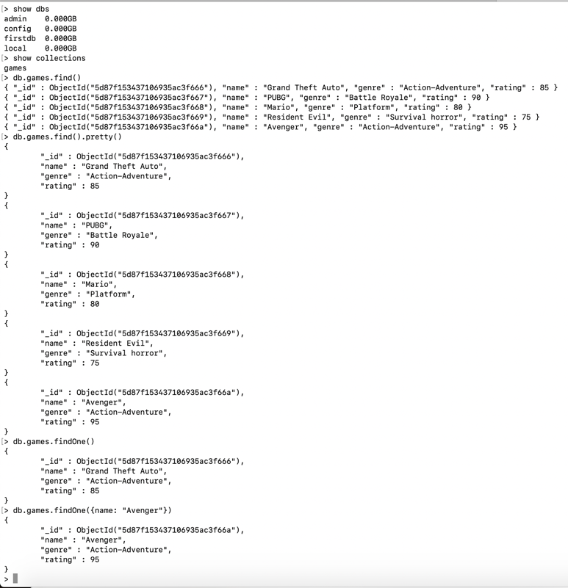

Write a query that returns the 3 highest rated games.

ANSWER:

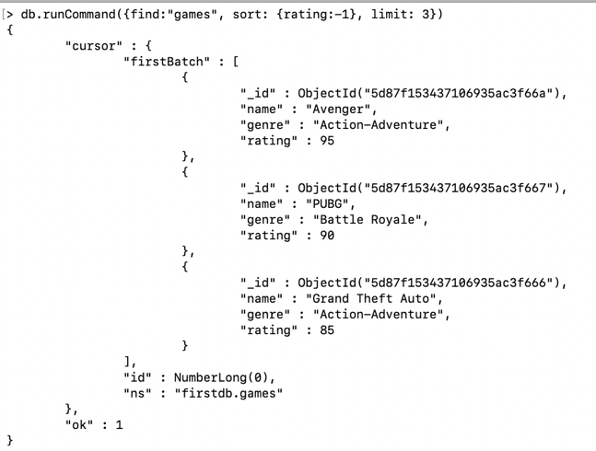

Update your two favorite games to have two achievements called ‘Game Master’ and ‘Speed Demon’, each under a single key. Show two ways to do this.  
Do the first using update() and do the second using save().

Hint: for save, you might want to query the object and store it in a variable first.

ANSWER:

1. Using update()

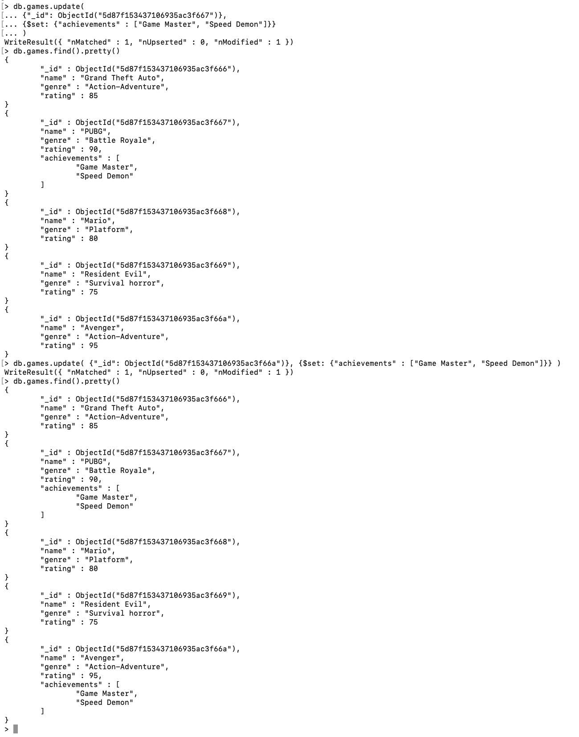

1. Using save()

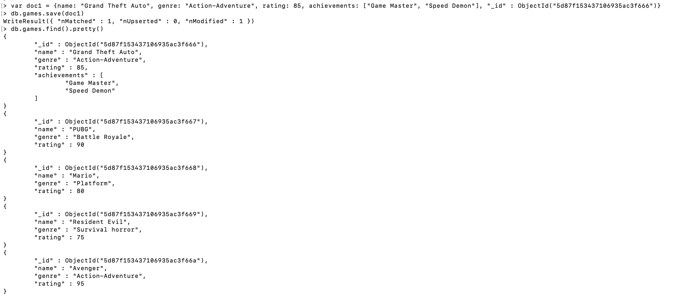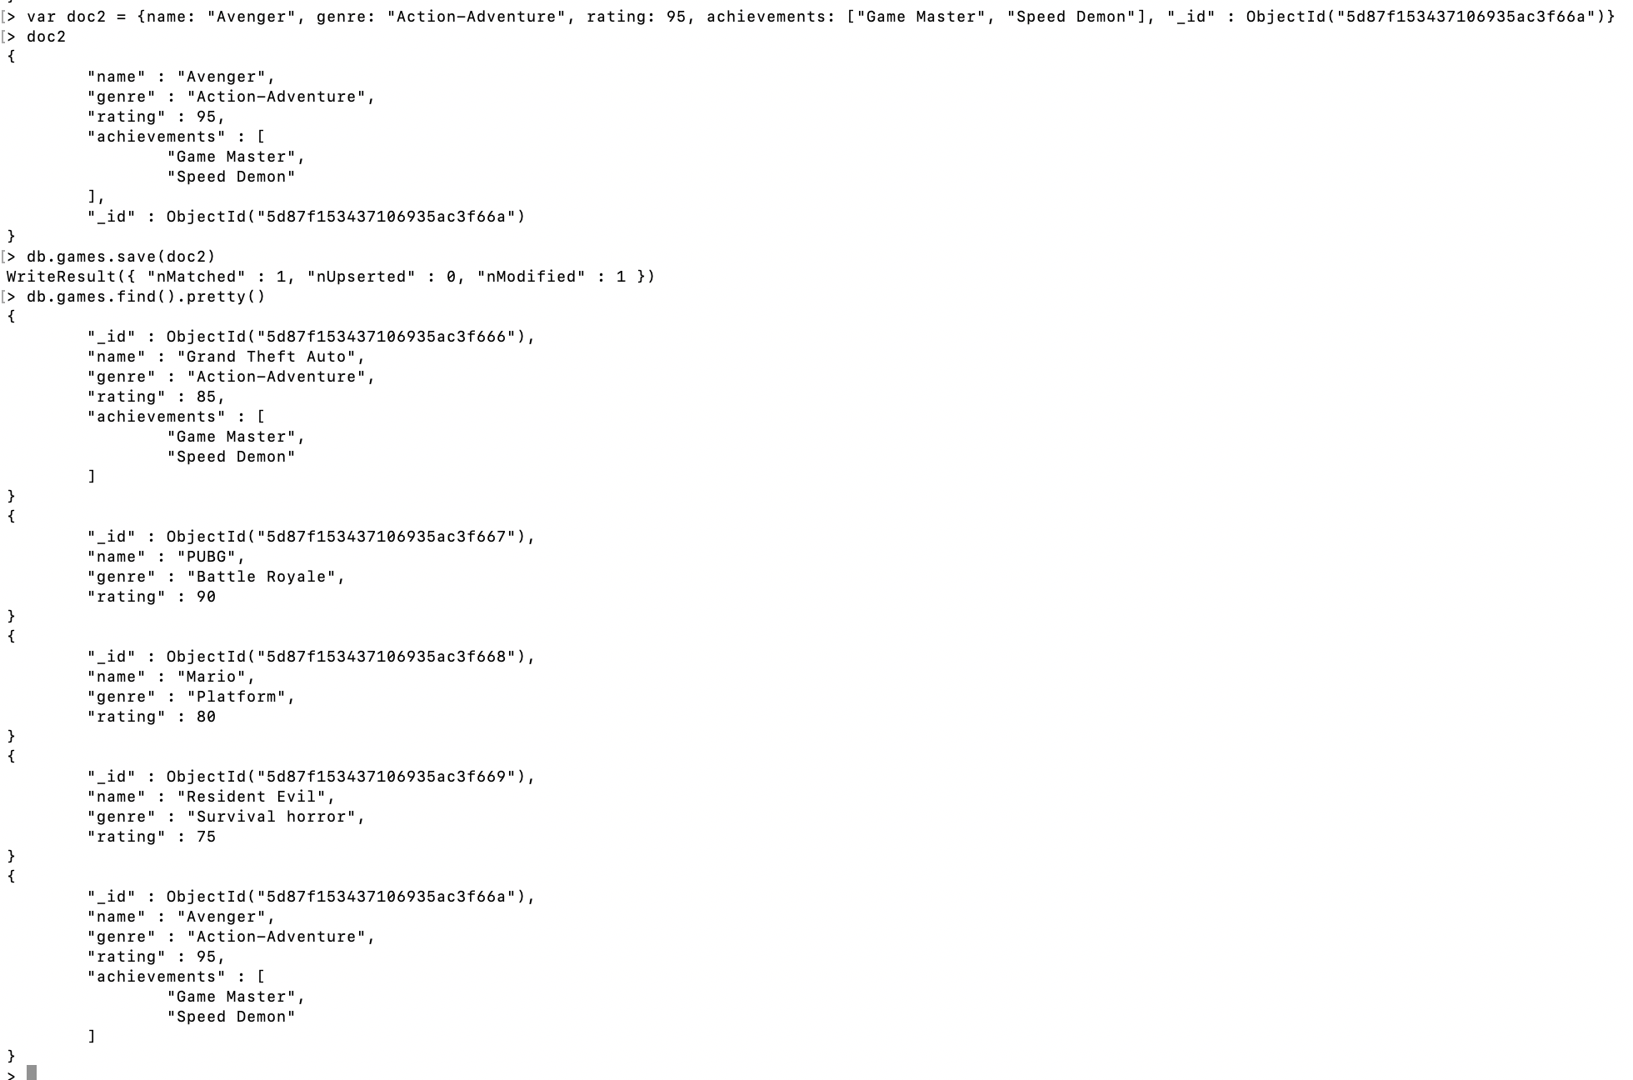

Write a query that returns all the games that have both the ‘Game Master’ and the ‘Speed Demon’ achievements.

ANSWER:

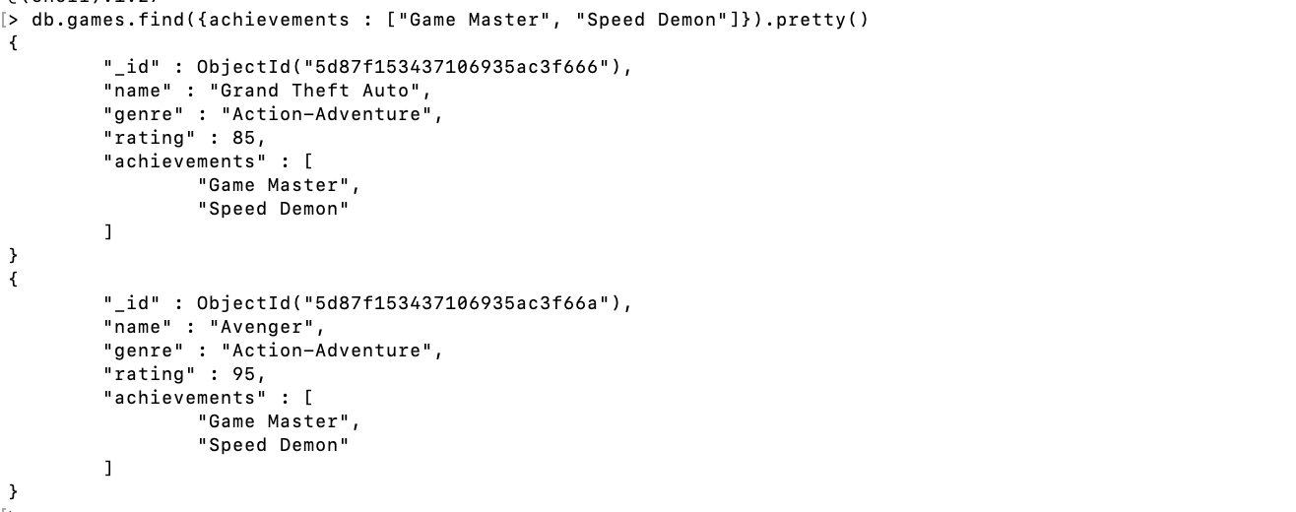

Write a query that returns only games that have achievements.

ANSWER:



**PROGRAMMING:**

ANSWER:

Please find movieLens.java file present under the mongodb folder as attached for the java code.

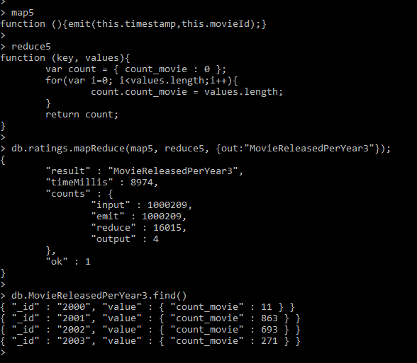

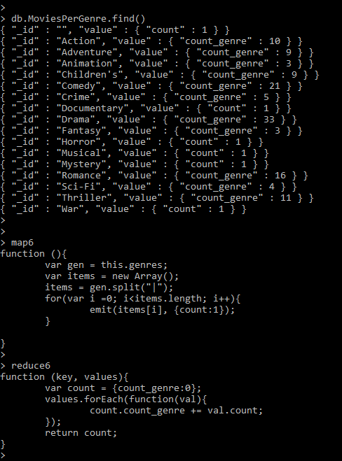

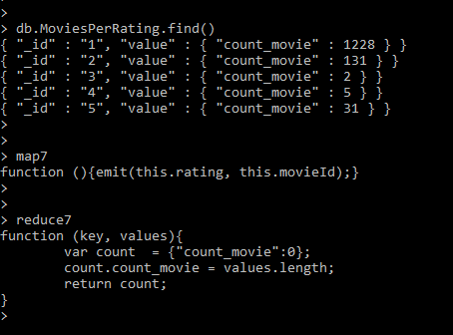

**PROGRAMMING:**

**ANSWER:**

Please find accessLog.java file under the mongodb folder as attached for the java code.

**Number of times any webpage was visited by the same IP address**

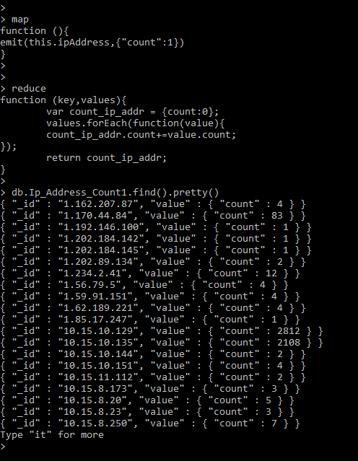

**Number of times any webpage was visited each month**

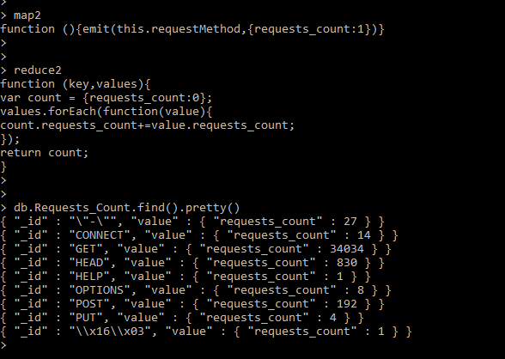

**PROGRAMMING:**

Execute 5 commands of your choice from each of the following groups.

mongo> help [5 commands]

ANSWER:

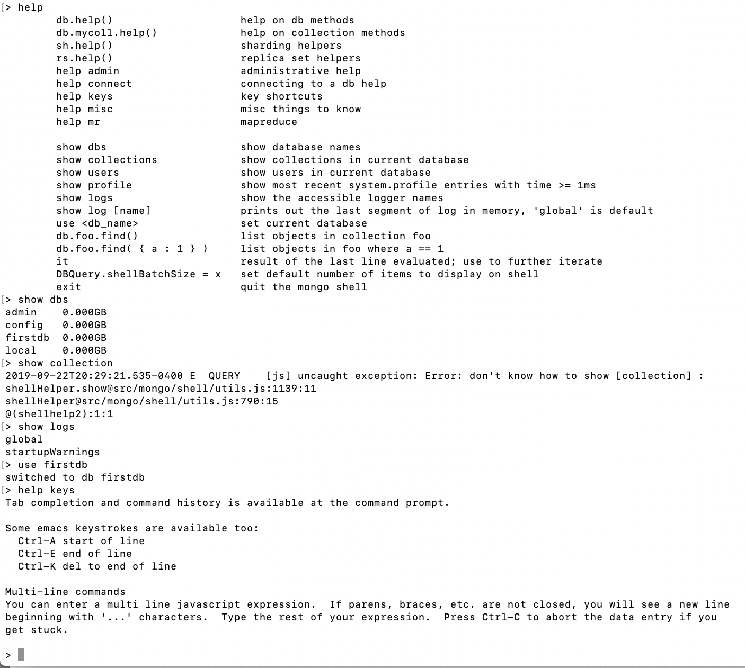

mongo> db.help() [5 commands]

ANSWER:

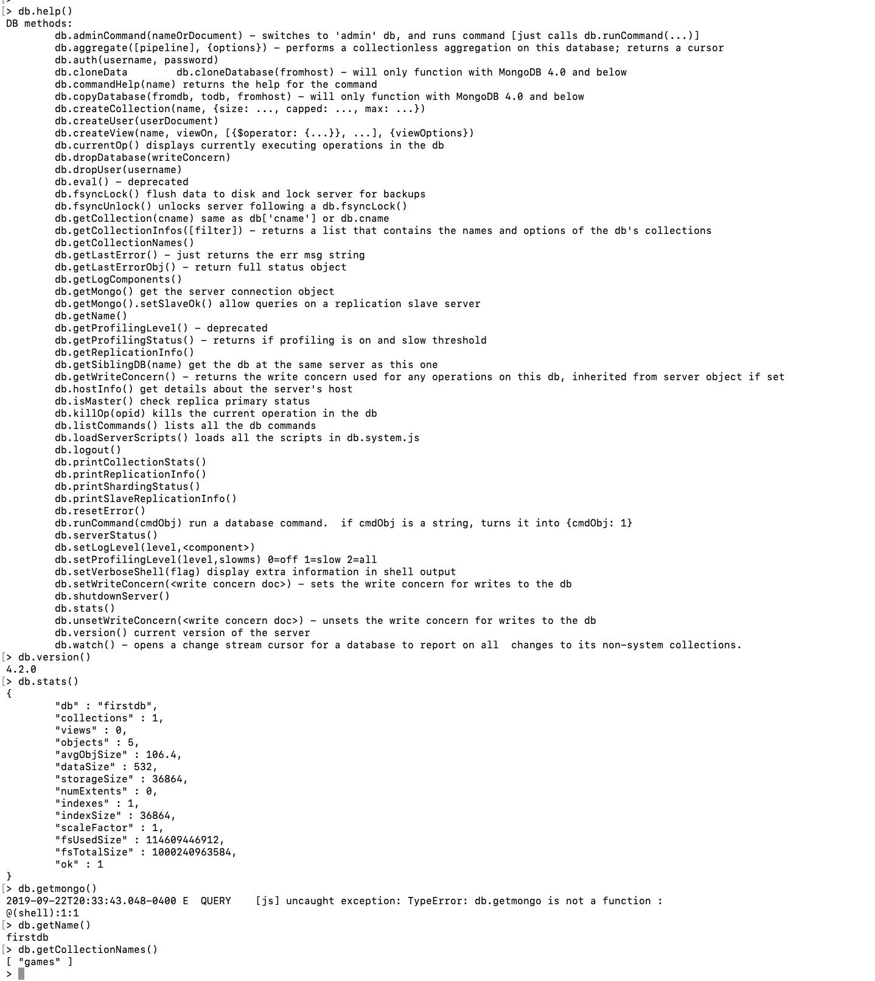

mongo> db.mycoll.help() [10 commands]

ANSWER:

Fisrt 5 commands -

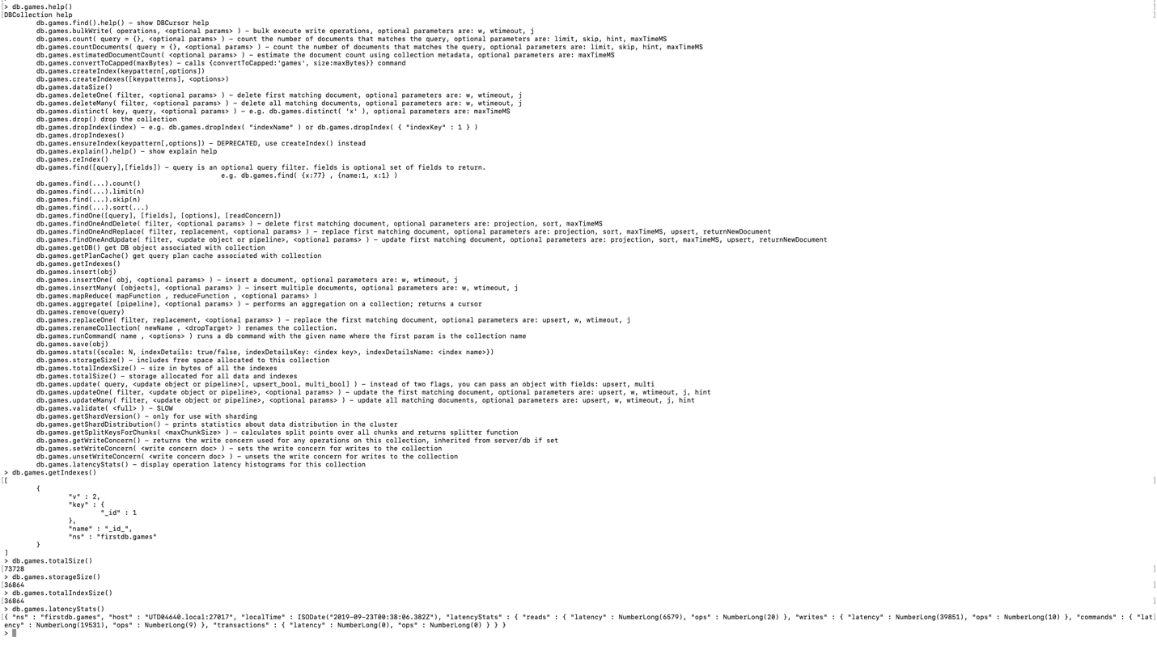

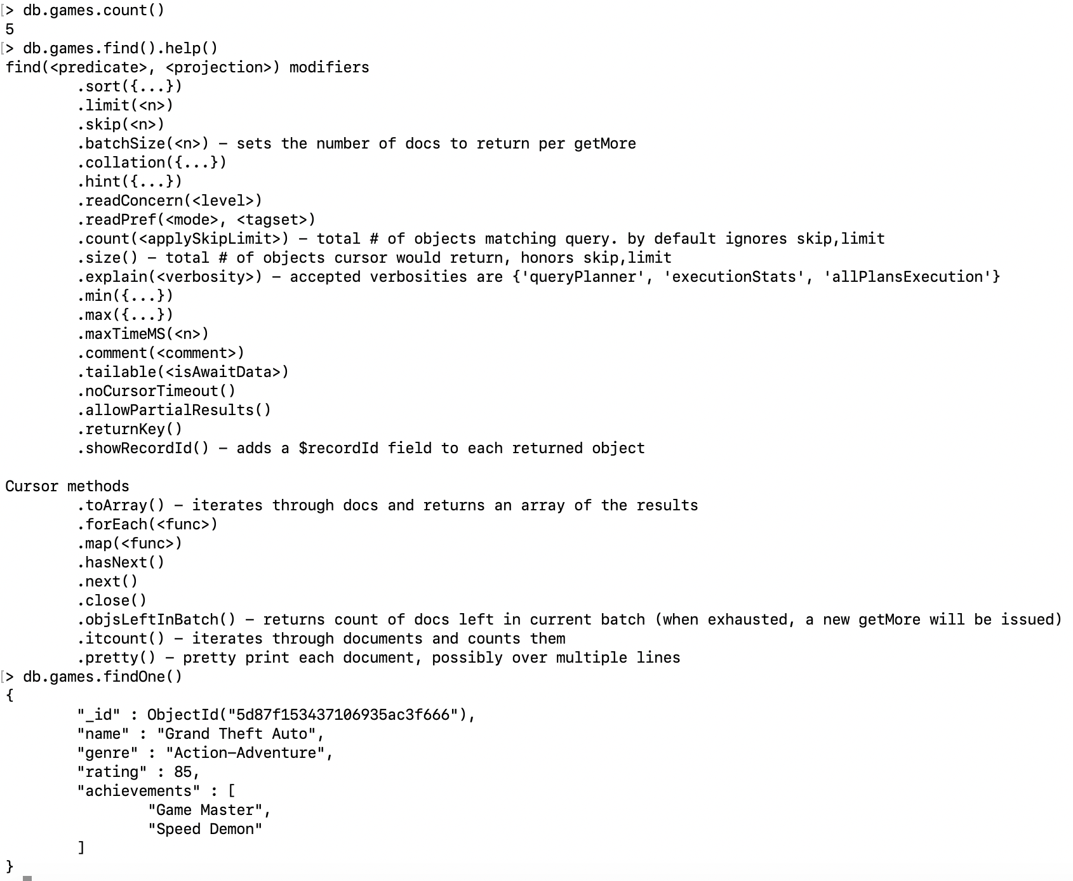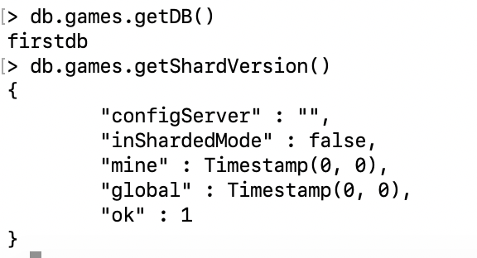

**PROGRAMMING:**

Write a .bat (for Windows) or .sh (for MacOS) to import the entire NYSE dataset (stocks A to Z) into MongoDB. NYSE Dataset Link: http://msis.neu.edu/nyse/nyse.zip

**ANSWER:**

Script –

